Hot Offers in CDH

Hot Offers is a command center for special one time offers which can help achieve a short term business goal. You can activate offers quickly, monitor the revenue and units sold they generate, and deactivate them when you achieve your goals or meet targeted thresholds.

**Hot offers is available in Pega CDH as Limited Availability. Further development is planned for future versions of the product.**

These are special issues that groups offers designed to generate revenue or units sold within a designated period of time and stages them in the Hot Offers landing page.

First we need to create issues and groups and most importantly we need to create the issue with the same name as Hot Offers and groups our wish however we want to create it

And now we have to create one action in order to show it in the Hot Offers tab.

Then we need to show in the tab.

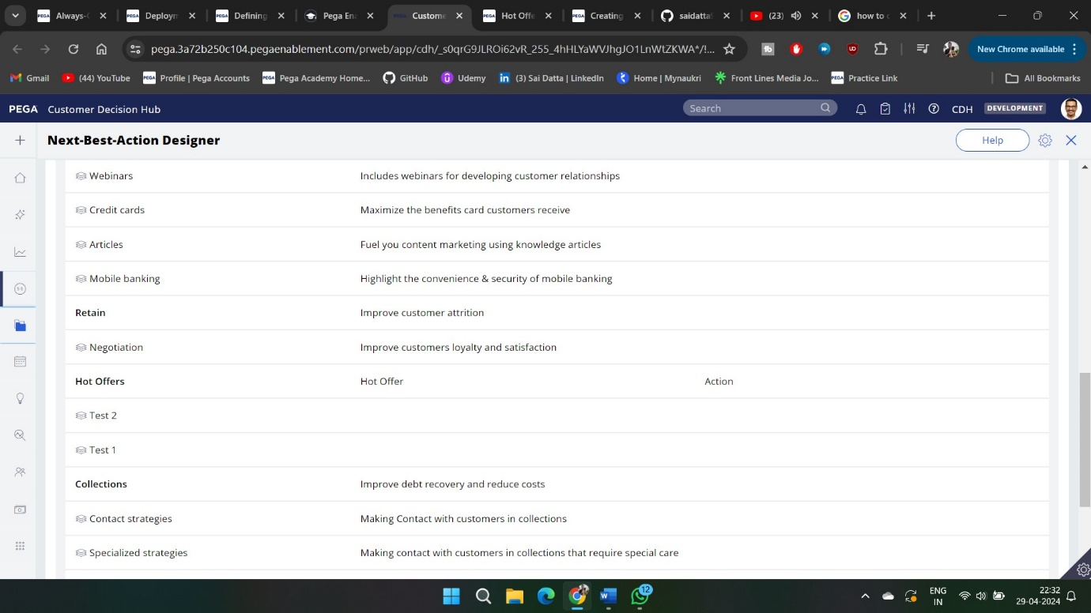

And then action also we need to create an action also

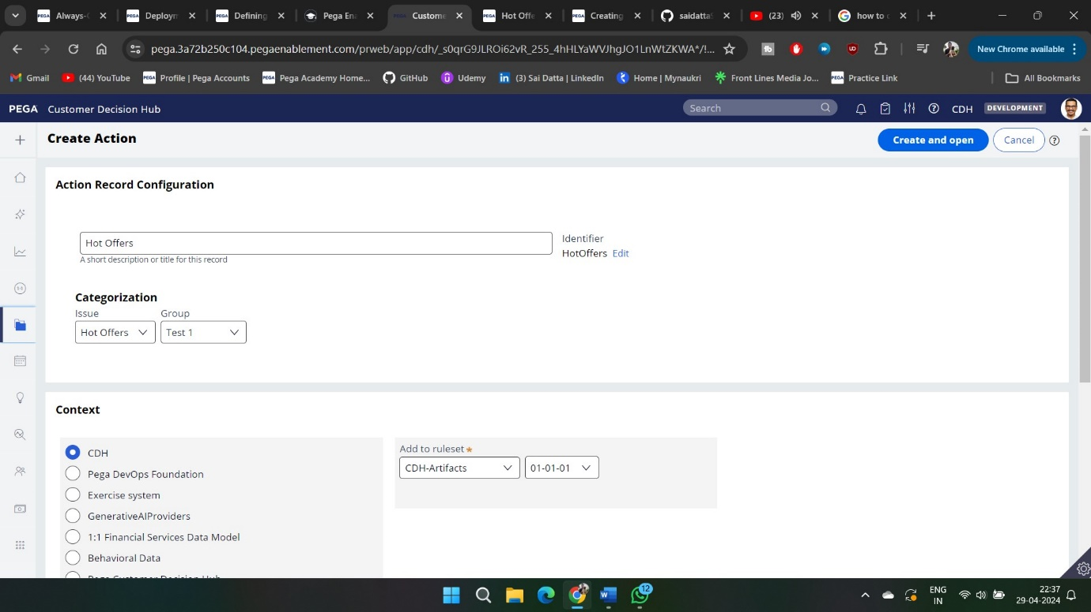

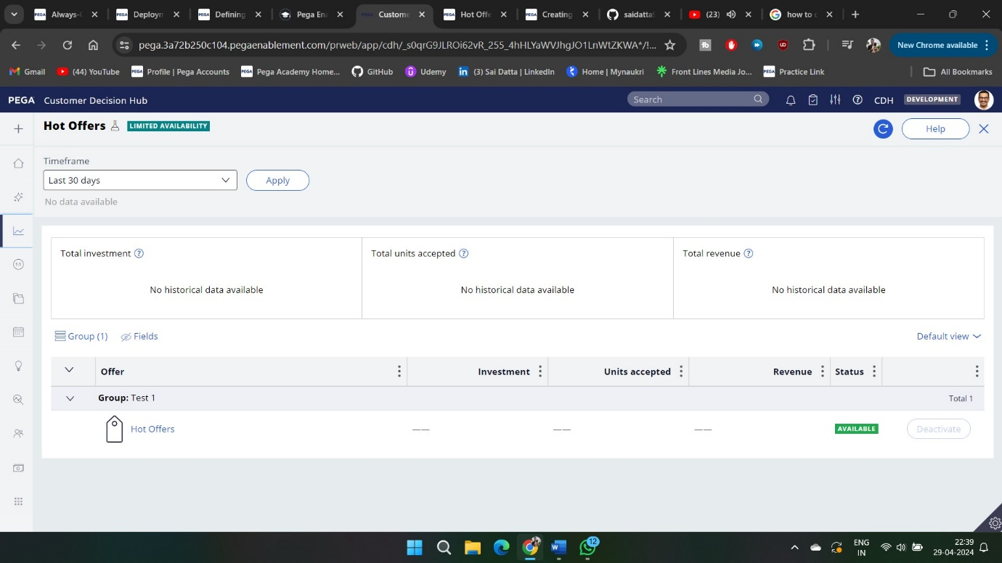

Now let us test in the customer profile viewer

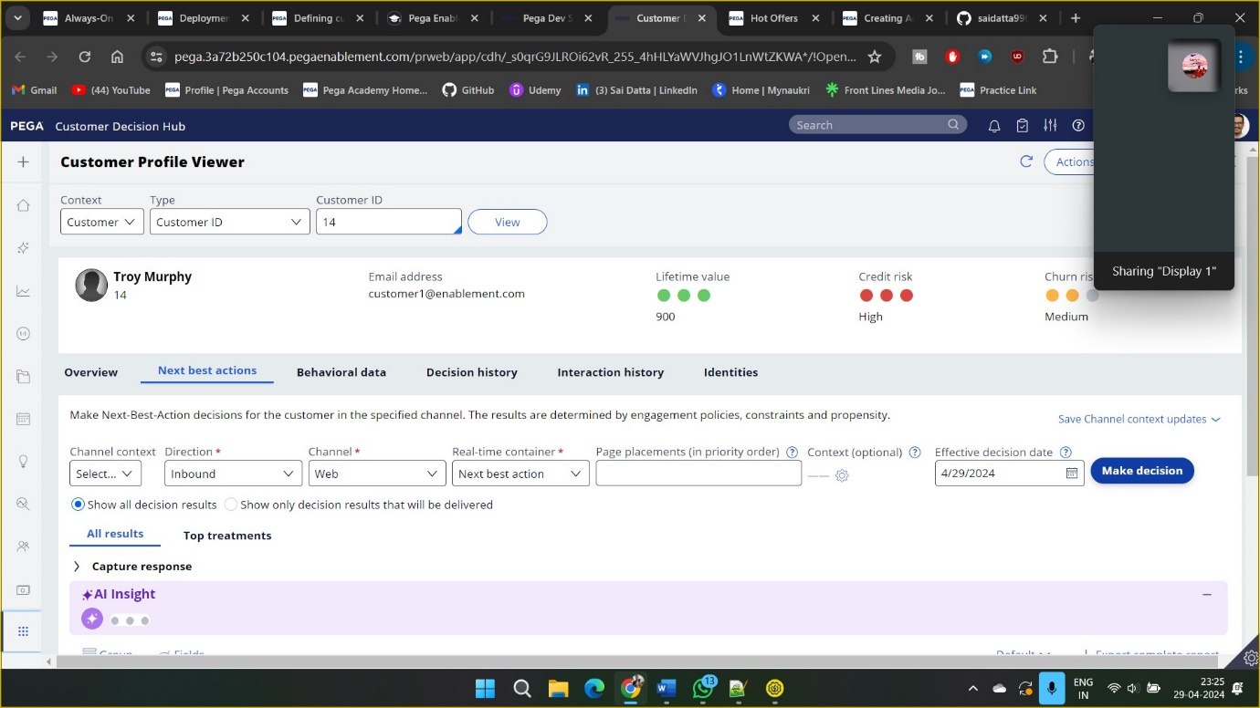

Now our offer is shown and also in the postman we are able to see the response

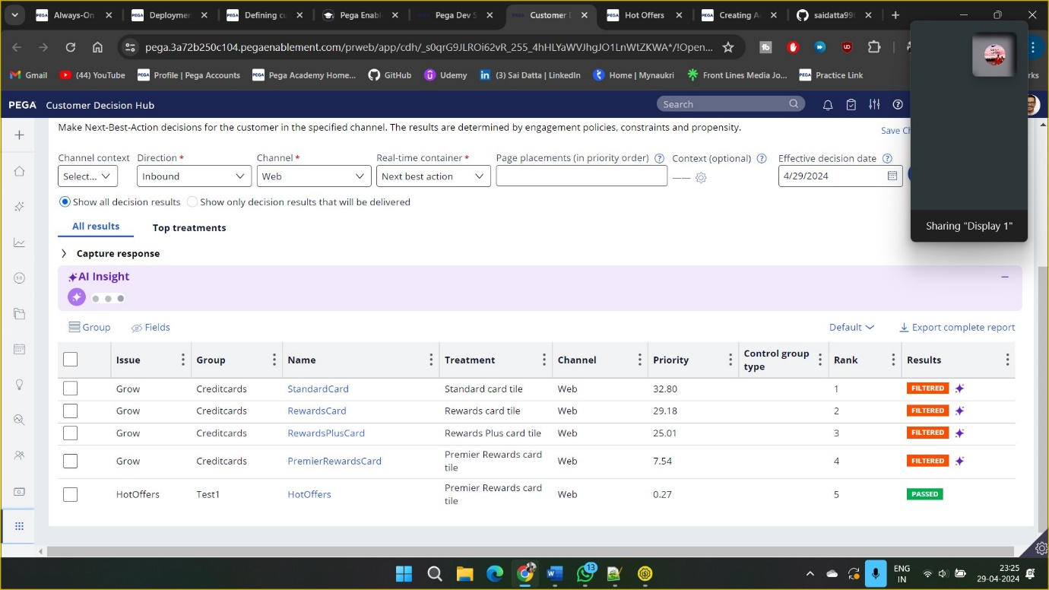

By using Real time container I tested off the offer in the postman and got the perfect result

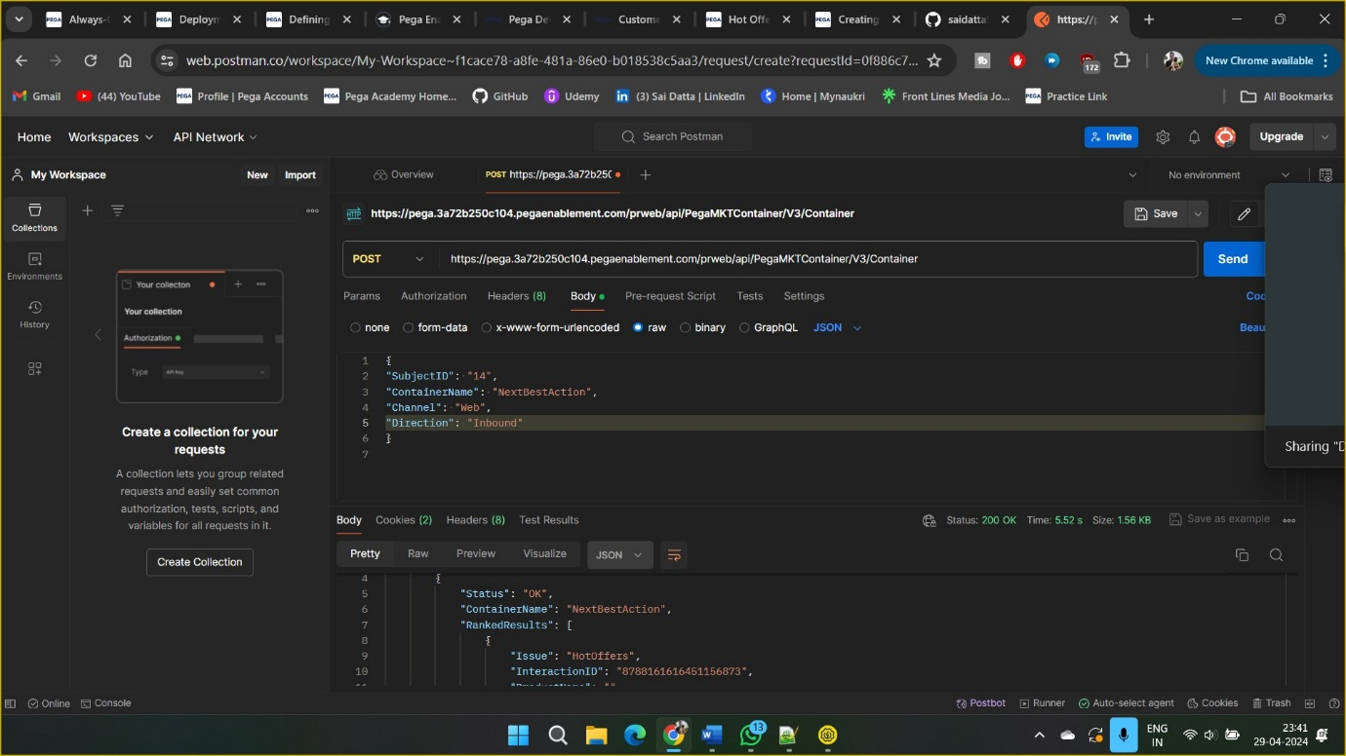

Basically why these hot offers are used is by giving the cost in the actions section.

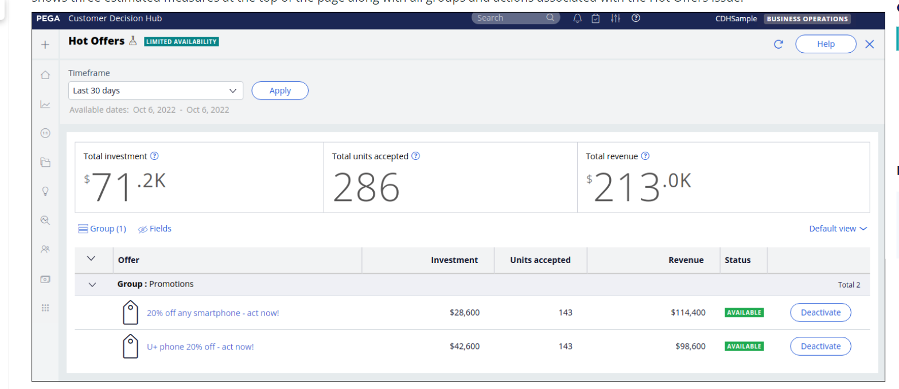

So it is all about Hot Actions